North Watford Cemetery

North Western Avenue

Watford

Hertfordshire

WD25 0AW

01923 672157 [cemeteries@watford.gov.uk](mailto:cemeteries@watford.gov.uk)

**Mulberry Tree**

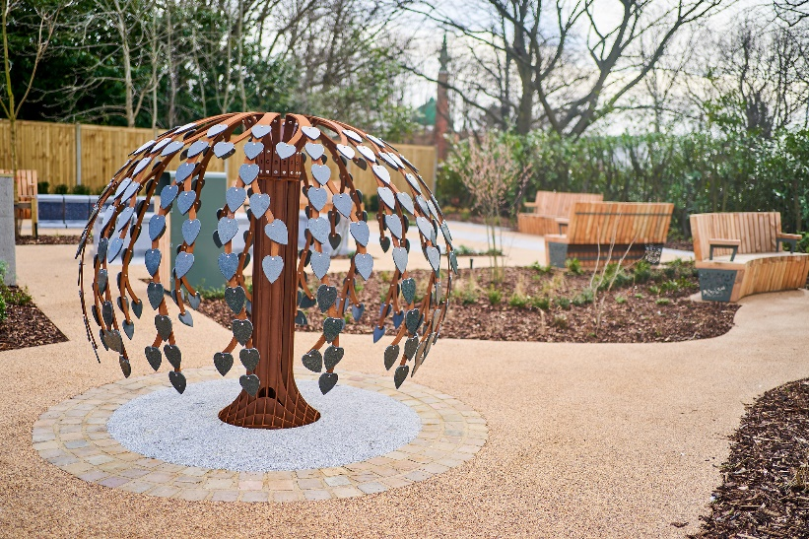

Our Mulbery Tree is a memory tree, with a hand carved granite trunk. The branches are made from weathered corten steel which quickly adopts an orange/brown anti–corrosion “Rust” finish which is practically no maintenace.

The hand made granite leaves can be sand-blasted with a basic inscription of up to 56 letters and there is a choice of motifs.

The lease is for a period of 5 years and includes a handmade heart shaped leaf with gilded letters. A design of either a Butterfly, Ladybirds, Four Leaf Clover, Acorn, Heart or Cross can be added for an additional cost. Please contact the Cemetery Office at the time of ordering should you wish to see examples of the motifs available.

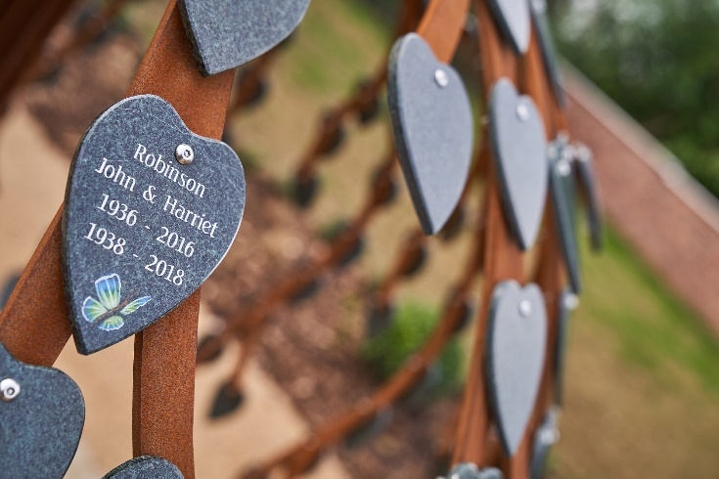

**Conditions of lease agreement – Mulberry Tree**

1. The lease of a memorial leaf relates only to the provision and placement by the Council of a heart shaped leaf on the memorial tree for the period of the lease. All items, including the memorial tree upon which the leaf is placed, are provided by and remain the property of Watford Borough Council (the Council) and are not included within the lease. No ownership of any item is inferred to, or may be assumed by, the lease holder.
2. In order that the cemetery grounds are maintained to the highest standard, the Council reserves the right to upgrade or renew, in similar style, any item, on which a leased leaf has been placed.
3. The lease is for a period of 5 years. There is an option to renew the lease agreement subject to payment of the fee then applicable.
4. Prior to the lease expiring, the Council will endeavor to contact the lease holder in order that the lease may be extended should the lease holder so wish. If the lease is not renewed on its expiry, the leaf will be removed from the tree and retained at the office for a 3 month period, during which time the lease holder may collect it. Any item remaining after 3 months will be disposed of sensitively.
5. The lease holder must advise the cemetery office of any change of address.
6. The lease holder and all visitors to the grounds must abide by the rules and regulations, copies of which are included with this application and within the cemetery grounds.
7. No items other than leaves provided and inscribed by the Council may be placed on the Mulberry Tree.
8. The hanging or fixing of flowers, ornaments, personal memorabilia, cards or other similar items from any memorials, trees or any other item within the cemetery grounds is not permitted.
9. The Council reserves the right to terminate the lease and remove and sensitively dispose of the leaf should there be any repeated breach of the rules and regulations or a single breach that the Council, considers to be of sufficient severity. If the lease is terminated by the Council no refund of the fee paid shall be made to the lease holder.
10. The Council reserves the right to refuse any inscription that is deemed to be unacceptable for display in a public place.
11. The Council cannot be held responsible for any damage whether accidental or willful that may occur to the leaf whilst in the cemetery grounds.

INSCRIPTION GUIDE BOX FOR MULBERRY LEAF

**Optional Artwork required (Please circle)** Butterfly Ladybirds Four Leaf Clover Acorn Heart Cross

|  |  |  |  |  |  |  |  |  |  |  |  |  |  |  |
| --- | --- | --- | --- | --- | --- | --- | --- | --- | --- | --- | --- | --- | --- | --- |
|  | **1** | **2** | **3** | **4** | **5** | **6** | **7** | **8** | **9** | **10** | **11** | **12** | **13** | **14** |
| LINE 1 |  |  |  |  |  |  |  |  |  |  |  |  |  |  |
| LINE 2 |  |  |  |  |  |  |  |  |  |  |  |  |  |  |
| LINE 3 |  |  |  |  |  |  |  |  |  |  |  |  |  |  |
| LINE 4 |  |  |  |  |  |  |  |  |  |  |  |  |  |  |

**GUIDELINES FOR FILLING IN INSCRIPTION**

1. NO MORE than ONE LETTER or NUMBER must be written in a box.
2. **DO NOT FORGET TO INCLUDE SPACES IN YOUR INSCRIPTION.** A space counts as a letter or number.
3. We will centre the text on the Leaf; this guide box is only to aid your choice of inscription.
4. The inscription **MUST** be clearly written in block capitals. ***We are unable to accept responsibility for any incorrect inscription due to illegible or ambiguous writing.***

Do you wish to be there when leaf is placed on the tree? YES/NO

(If YES we will contact you when the inscribed leaf has been received to arrange a suitable appointment)

.

I enclose the fee of £……………………………….. for the lease of a leaf to be attached to the Mulberry Tree in North Watford Cemetery for a period of 5 years. I agree to the terms and conditions set out above.

|  |  |
| --- | --- |
| Name: | |
| Address: | |
|  | |
|  | |
| Post Code: | Telephone No: |
| Email: |  |
| Signature |  |

|  |  |  |  |
| --- | --- | --- | --- |
| **Office Use Only:** |  |  |  |
| **Purchase Date** | **Agreement Number** | **Receipt Number** | **Position of leaf** |
|  |  |  |  |
| **Expiry Date** | **Appointment Date & Time** | **Completed by** |  |